Documentation:

Task 3/4:
- Test A: HTML Injection (Unsafe Page):
- What the Screenshot Shows: HTML tags like <u> and <h1> were typed into the input field. The application printed the text, but it made the text underlined and massively large.
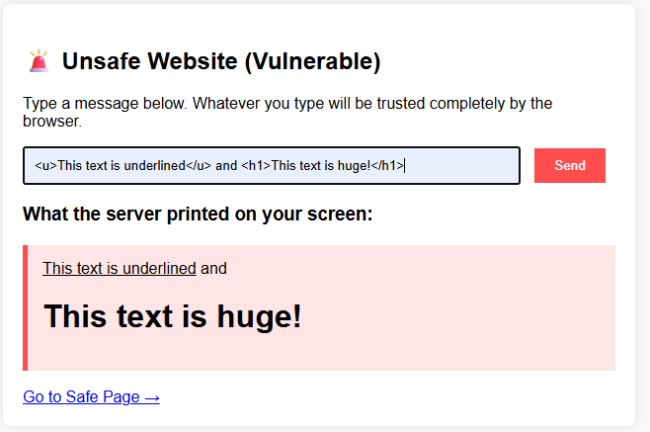
- The Cyber Concept: Lack of Input Validation. The server took the input and dropped it straight into the website's structure using raw Python string formatting (%s). Because there were no checks, the browser couldn't tell the difference between code written by the developer and text typed by a random user. It treated the input as instructions, letting an attacker change how the website looks.

- Test B: JavaScript Injection / Cross-Site Scripting (Unsafe Page):
- What the Screenshot Shows: A <script> tag containing an alert () function was typed into the input field. The moment the input was entered and sent, a pop-up window snapped onto the screen saying the user had been hacked.
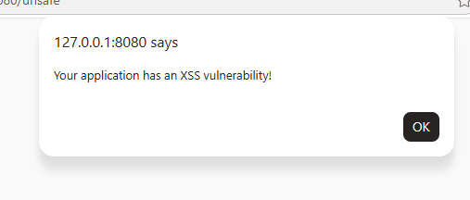
- The Cyber Concept: Stored/Reflected XSS (Cross-Site Scripting). This is an intermediate web vulnerability. Because the page didn't check the input, an executable programming code was successfully injected directly into another user's session. In a real-world chat application, a hacker could use this exact trick to silently steal session tokens, capture keystrokes, or redirect users to a fraudulent website.

3. Test C & D: The Defensive Fix (Safe Page with HTML & JS Injection)
- What the Screenshot Shows: The exact same HTML (<h1>) and JavaScript (<script>) code were typed the into the safe page box. Instead of breaking or creating pop-ups, the page safely displayed the text exactly as you wrote it, brackets and all.
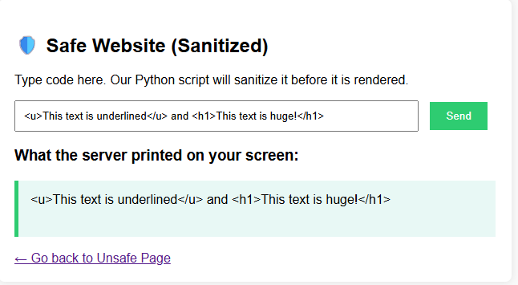
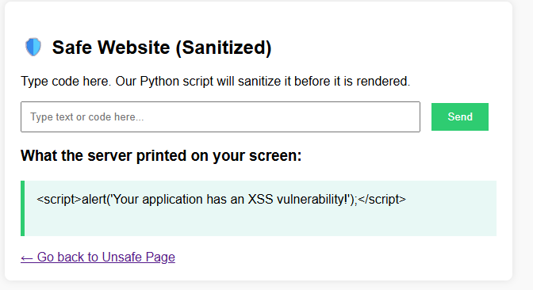

- The Cyber Concept: Input Sanitization & HTML Entity Encoding. This is the core defence mechanism. Before letting the input touch the screen, the Python backend intercepted the text and replaced dangerous control characters with HTML Entities:
Raw Character | Harmless HTML Entity | What the Browser Does
< | &lt; (Less Than) | Draws < visually but stops it from opening a code tag.
> | &gt; (Greater Than) | Draws > visually but stops it from closing a code tag.
& | &amp; | Prevents rendering bypasses.

